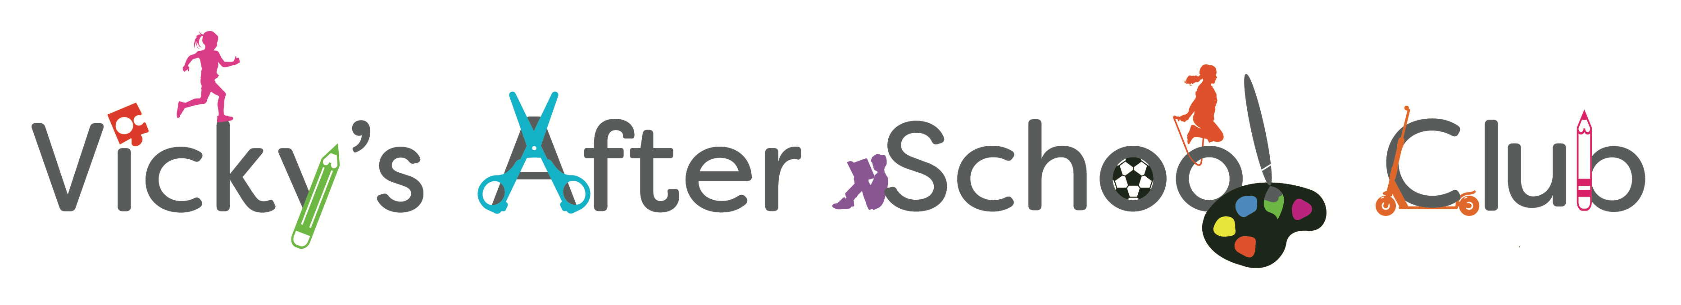
Playworker Vacancy for Breakfast and/or
After School Club at
John Blandy Primary School
Do you enjoy working with children and having fun? Are you a good team player and do you love to support children in their learning and development just by Playing? If the answer is yes, this could be the job for you.

Vicky’s After School Clubs are privately owned and Vicky will ensure you receive the training you will need to succeed in your role and encourage you to be the best you can be. We are seeking engaging, reliable, caring and enthusiastic Playworkers to work with children between the ages of 4-11. You will be working in a fun and engaging environment as part of a fantastic team.
Hours are: Mon - Fri 7.30-8.45 am Breakfast Club and/or
Mon - Thurs 2.30 – 5.30 pm Fri 2.30 – 5.00 pmAfter School Club
(this position could be a job share and is flexible)
Term Time only (Holiday work available)
Salary dependant on experience and qualifications.
Minimum age 18 years (Ofsted requirement)
Please note that an enhanced DBS check will be undertaken as part of the recruitment process.

If you are interested and would like further information, please contact:
Vicky Hickman Tel No: 07887711454
Email: info@vickysafterschoolclub.co.uk
website: www.vickysafterschoolclub.co.uk

