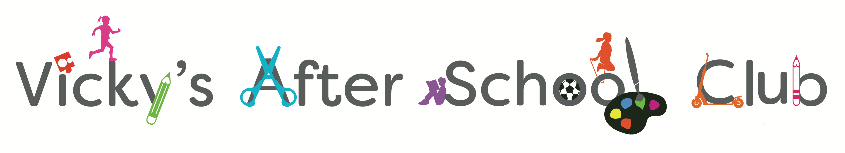

Vacancy –Playworker Assistant
(part-time, term-time only)

At Vicky’s Breakfast & After School Club we aim to provide a safe, secure and relaxed environment, offering a range of activities to reflect the interests of the children in our care. We believe in continous support and traning for all our staff and we encourage them to be the best they can be.

We are looking for a motivated Playworker Assistant to join our club at John Blandy Primary School and work alongside the existing team already in place.

First and foremost you must enjoy working with children aged between 4 – 11 years old. You must be prepared to organise varied and creative play, taking the children’s own interests into account.

Full training will be given in all areas but enthusiasm and a passion for working with children is essential.
An enhanced DBS check will be carried out prior to joining.

If you are the person we are looking for, please contact us via the contact details below.

Vacancies – Part-time Playworker Assistant

Hours – 2.45pm – 5.00pm. Days to be discussed.

Salary – Negotiable

Contact details - Please see below

Email: vickyhickman1@gmail.com Tel No: 07887 711 454

Website: vickysafterschoolclub.co.uk

